Nowhere to Belong: The Rohingya’s Identity Crisis from Myanmar to Bangladesh
Emma Liang
Who are we without a sense of identity?
Identity shapes how individuals see themselves in relation to the world. When it is undermined—considered inferior, illegitimate, or outright threatened—entire communities face devastating consequences. (Acha, n.d.)
The Rohingya, a Muslim ethnic minority from Myanmar, are grappling with a multi-faceted identity crisis. Denied citizenship and rendered stateless, they have lost their national identity. Deprived of basic human rights—the foundation of dignity and shared recognition—their very humanity is called into question. And as younger generations born and raised abroad lose the valued connection to Myanmar as their ancestral home, their cultural identity is eroded.
The fragmentation of their identity underscores the essential need for belonging and mutual recognition. It highlights how violence and persecution can erase these fundamental aspects of humanity.
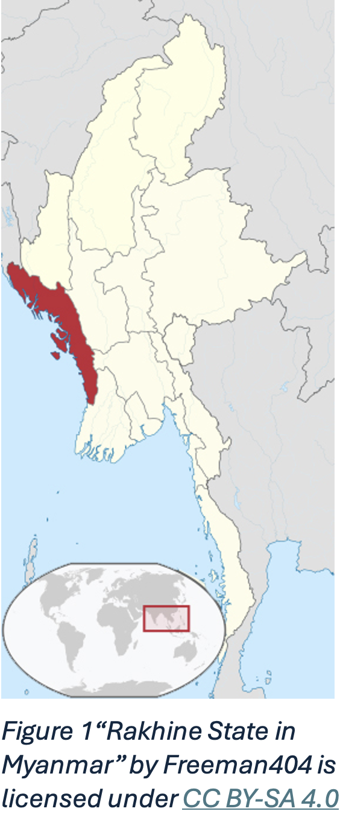

From Citizenship to Camps: Tracing the Rohingya’s Journey
“We are citizens of Myanmar.”-Khin Maung, 29-year-old (MSF, 2021)
The Rohingya have resided in the Rakhine state of Myanmar for centuries (Medecins Sans Frontiers Doctors Without Borders, n.d.). Over recent decades, they have suffered escalating persecution from the Myanmar government, leading to the displacement of approximately 1.2 million people. The majority fled to Bangladesh, while others sought refuge in Malaysia, Cambodia, Thailand, and India.
Cycles of targeted violence against the Rohingya began in 1962 and grew increasingly severe. By 1978, the first wave of refugees fled to Bangladesh after the Myanmar government (then known as Burma) confiscated Rohingya national ID cards, marking the onset of the dissolution of Rohingya identity within Myanmar. This erasure became formalized in 1982 when the Citizenship Law excluded the Rohingya from Myanmar’s 135 official “national races,” rendering them stateless (MSF, 2022c).
In 2017, the United Nations described the violence against the Rohingya as the largest campaign of targeted violence in modern history. Unsuccessful retaliation by militant Rohingya groups escalated the crisis. Widespread violence, including the destruction of villages, forced 750,000 Rohingya to flee, joining those who had escaped earlier waves of persecution. This exodus transformed Kutupalong in Cox’s Bazar, Bangladesh, into the world’s largest refugee camp, housing over 1 million Rohingya (UNICEF, 2024).
The 140,000 Rohingya who remained in Myanmar became internally displaced. Without legal identity or citizenship, they were confined to squalid camps in the Rakhine state, deprived of basic rights and freedom of movement (MSF, 2022b).
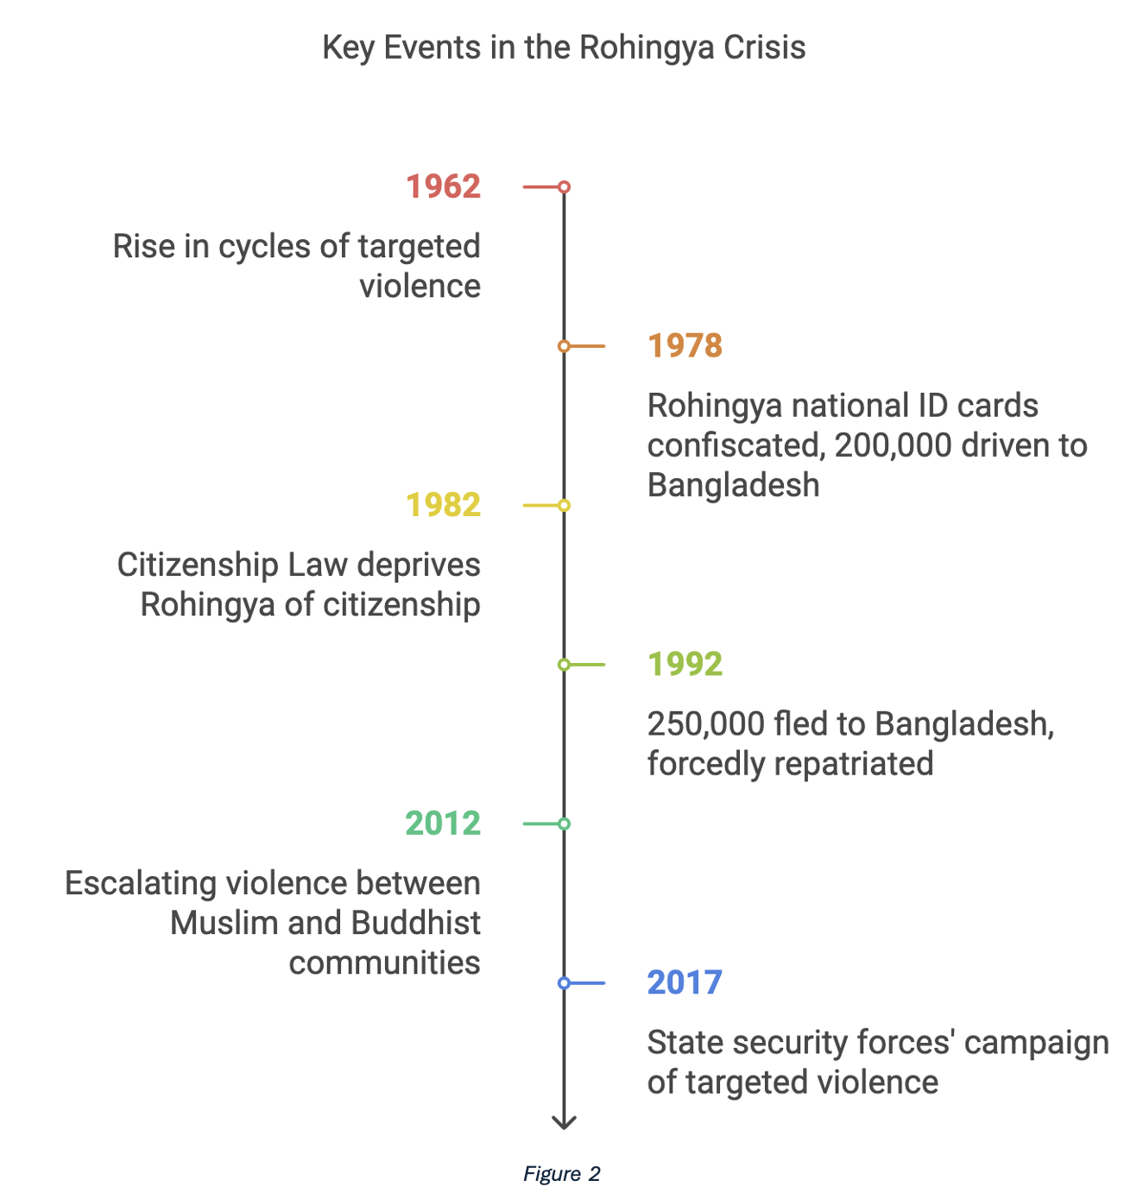

Stateless and Stranded: National Identity
“In the country where our ancestors have been living, we could no longer vote.”-Mohamed Hussein, 65-year-old (MSF, 2022d)
The Rohingya are considered stateless under international law. MSF Humanitarian Affairs Coordinator Gina Bark explains: “A stateless person is someone who is not recognised as a citizen under the laws of any country. They hold no nationality.” For the Rohingya, neither their home country nor their host countries legitimise their national identity (MSF, n.d.).
Prior to 1978, as seen in many contemporary nations, the Rohingya were recognised as citizens if both the father and child were born in Myanmar. This fundamental and nearly universal rule was unexpectedly dissolved in 1982, effectively subordinating the Rohingya’s national identity.
The physical separation of the Rohingya in Bangladesh further reinforces the estranged relationship between nation and person. Since early 2018, Myanmar authorities have reportedly cleared abandoned Rohingya villages to build security bases and infrastructure under the pretext of preparing for the repatriation of refugees. Critics argue that this, alongside the earlier destruction of 50% of Rohingya villages, is only intended to benefit the remaining population. In a sense, it is the deliberate cultural erasure of Rohingya’s national identity (MSF, 2022d).
The Rohingya are also not recognised as refugees in Bangladesh. In 2019, the Bangladeshi government announced that it would no longer accept any Rohingya fleeing Myanmar. This rejection by both countries transforms the most fundamental relationship between a person and their state into one of hostility. What should be an embracing home that protects its citizens has become the primary threat to the Rohingya’s well-being and identity (BBC, 2020).

I Am Human: The Struggle for Recognition
“Sometimes I feel as if I am not human. I feel as if I am living deep in a forest with wild animals, having nothing to call my own—no education, no safety, not even freedom.”-Khin Maung
The lack of nationality for the Rohingya in both Myanmar and Bangladesh also denies them legal protection and access to basic human rights, including freedom of movement, healthcare, education, and employment, challenging the Rohingya’s identity as a human.
Barbed wire fences further isolate the camps, limiting interaction with the outside world. Gates are guarded by police and military personnel; Mohamed Hussein shared how this makes visiting his daughter in another camp extremely difficult, feeling it violates his dignity as a human being (MSF, n.d.).
Additionally, Rohingya refugees face restricted access to better-equipped hospitals, which is detrimental as they are highly susceptible to waterborne diseases, with over 60% of the available water supply contaminated (MSF, 2022d).
More than 400,000 of the 600,000 children in Kutupalong lack access to education due to restrictions on using either Bangladeshi or Myanmar curricula in the camps. Rohingya children are also prohibited from enrolling in schools outside the camps. This creates the risk of a "lost generation," unable to integrate into wider society socially or economically in the future. The lack of educational and employment opportunities further raises their vulnerability to trafficking, perpetuating their objectification (Albert & Maizland, 2020).
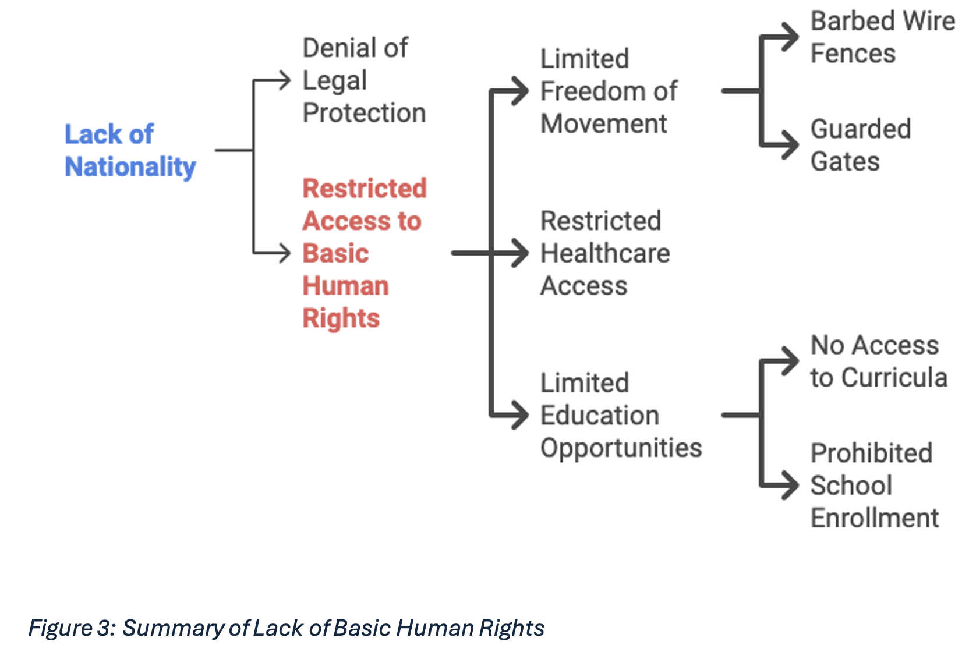
Without employment, the majority of Rohingya are almost entirely reliant on humanitarian assistance for basic needs such as food, water, shelter, and healthcare.
The COVID-19 pandemic exacerbated these challenges. Already limited freedoms were further curtailed as movement was strictly restricted, reducing access to healthcare even for severe cases (MSF, n.d.). Unlike other regions, exceptions were not made, stripping refugees of dignity. Mohamed Hussein remarked, “Now that all our rights have been taken away, we are nothing but a walking corpse.”
The pandemic also led to the shutdown of small businesses, making refugees entirely dependent on aid. This collective denial of autonomy and basic rights erodes their sense of humanity. As Mohamed Hussein said, “I ask the world to help us live as humans.” (UNICEF, 2024).

Complications From Within: The Erosion of Cultural Identity
“Why wouldn’t we return if justice is served to us and we are given citizenship? Is it not our homeland also?”-Tayeba Begum (MSF, 2022d)
The Rohingya have lived on the land of Rakhine state, then part of the Arakan Kingdom, since the 15th century. This deep-rooted history and connection to their land is reflected in their self-identifying term, “Rohingya.” Rohang is thought to derive from the word “Arakan,” and gya means “from” in the local dialect. Today, this sense of ancestry resonates strongly with many of the population. Their great desire to return home, yet inability to do so, not only strains their national identity but, when not valued as strongly by the younger generation, threatens their cultural identity and risks creating generational displacement (Albert & Maizland, 2020).
Aid workers in Kutupalong found that the older generation’s primary worry is over the status of Myanmar and the possibility of return.
Nabi Ullah, who fled to Bangladesh with his family in 2017, said, “We all miss our home terribly. I do not even feel like eating when memories of Myanmar come back.” Similarly, Hashimullah observed the situation in 2017 for eight days in the hope that it would improve, leaving reluctantly when it worsened. He says, “We have escaped here, but our hearts are still there at home.”
The sentiment, however, is not shared to the same degree by children, who were mostly raised—and some born—in this “limbo.” The younger generation often feels a weaker emotional connection to Myanmar, with most memories tied to the horrors of fleeing. Their focus is on immediate concerns such as education and employment.
For example, Anwar’s, a 15-year-old boy in Kutupalong, main concern is the interruption to his and other children’s education, as they have no access to resources like books. He dreams of becoming a doctor but fears that this aspiration will never come true.
Although parents greatly worry about their children’s education and future, just as children care about Myanmar’s state, these concerns are to a lesser degree. The younger generation is more open to the idea of living abroad, reflecting a fragmentation of the value of Myanmar as the Rohingya homeland and challenging their cultural identity (MSF, 2022d).
However, this fragmentation is not severe as many shared values remain; both parents and children emphasize their desire for a Myanmar education curriculum (UNICEF, 2024).

A Home to Hope For
Although the UN and NGOs like Doctors Without Borders have raised awareness of the Rohingya crisis, there is a growing fear that it is becoming “invisible” on the international agenda. This fuels a sense of hopelessness among the Rohingya, as the dream of returning home feels increasingly unattainable (MSF, 2022d). Hashimullah reminds us, “Our shelters are still as temporary as when we arrived.” Myanmar is their home, and there must be a united global commitment to securing their return—restoring not just the Rohingya’s homeland, but their right to belong.

Bibliography
Acha, K., n.d. The 7 Fundamental Human Needs. [Online]
Available at: https://www.servantsuniversity.com/the-7-fundamental-human-needs/
[Accessed 11 12 24].
Albert, E. & Maizland, L., 2020. The Rohingya Crisis. [Online]
Available at: https://www.cfr.org/backgrounder/rohingya-crisis#:~:text=The%20Rohingya%20trace%20their%20origins,as%20part%20of%20British%20India
[Accessed 11 12 2024].
BBC, 2020. Myanmar Rohingya: What you need to know about the crisis. [Online]
Available at: https://www.bbc.com/news/world-asia-41566561
[Accessed 11 12 2024].
Medecins Sans Frontiers Doctors Without Borders, n.d. The Rohingya: The World's Largest Stateless Population. [Online]
Available at: https://msf.org.au/rohingya-worlds-largest-stateless-population
[Accessed 11 12 2024].
MSF, 2021. Rohingya Refugees: "We Could Simply Become Invisible". [Online]
Available at: https://msf.org.au/article/stories-patients-staff/rohingya-refugees-we-could-simply-become-invisible
[Accessed 11 12 2024].
MSF, 2022. "One Can Begin Living as a Human": Why Resettlement Is Urgent For the Rohingya. [Online]
Available at: https://msf.org.au/article/project-news/%E2%80%9Cone-can-begin-living-human%E2%80%9D-why-resettlement-urgent-rohingya
[Accessed 11 12 2024].
MSF, 2022. Myanmar: After 10 Years in Camps, Rohingya Mental Health Continues to Suffer. [Online]
Available at: https://msf.org.au/article/project-news/myanmar-after-10-years-camps-rohingya-mental-health-continues-suffer
[Accessed 11 12 2024].
MSF, 2022. Rohingya: A Timeline. [Online]
Available at: https://msf.org.au/article/project-news/rohingya-timeline
[Accessed 11 12 2024].
MSF, 2022. Rohingya: Five Stories From Five Years of Displacement. [Online]
Available at: https://msf.org.au/article/stories-patients-staff/rohingya-five-stories-five-years-displacement
[Accessed 11 12 2024].
UNICEF, 2024. Rohingya Crisis. [Online]
Available at: https://www.unicef.org/emergencies/rohingya-crisis
[Accessed 11 12 2024].

